A Project Report on
WEATHER-BASED PREDICTION OF WIND TURBINE ENERGY OUTPUT USING MACHINE LEARNING
Industrial Internship Project report submitted in partial fulfillment of the Requirements for the award of the degree in

BACHELOR OF TECHNOLOGY
IN

CSE (ARTIFICIAL INTELLIGENCE & DATA SCIENCE)
BY
V DIVYA NANDINI 228X1A4545
N SAI CHANDRA DEEP 228X1A4530
K POOJITHA SAI 228X1A4515
P RAVINDRA 228X1A4559
G MANOHAR 228X1A4565

Under the Esteemed Guidance of
Mr. V. MARAGASACHARY
Assistant Professor

DEPARTMENT OF CSE (ARTIFICIAL INTELLIGENCE & DATA SCIENCE) KALLAM HARANADHAREDDY INSTITUTE OF TECHNOLOGY (AUTONOMOUS)
ACCREDITED BY NAAC WITH ‘A’ GRADE (APPROVED BY AICTE, AFFILIATED TO JNTUK, KAKINADA)
NH-5, CHOWDAVARAM, GUNTUR - 522019 2022 - 2026

KALLAM HARANADHAREDDY INSTITUTE OF TECHNOLOGY (AUTONOMOUS)
ACCREDITED BY NAAC WITH ‘A’ GRADE (APPROVED BY AICTE, AFFILIATED TO JNTUK, KAKINADA)
NH-5, CHOWDAVARAM, GUNTUR - 522019 DEPARTMENT OF CSE (ARTIFICIAL INTELLIGENCE & DATA SCIENCE)
CERTIFICATE

This is to certify that the Industrial Internship Project work entitled WEATHER-BASED

PREDICTION OF WIND TURBINE ENERGY OUTPUT USING MACHINE LEARNING

being submitted by V. DIVYA NANDINI (228X1A4545), N. SAI CHANDRA DEEP (228X1A4530),

K. POOJITHA SAI (228X1A4515), P. RAVINDRA (228X1A4559), G. MANOHAR (228X1A4565)

in partial fulfilment for the award of the Degree of Bachelor of Technology in CSE (Artificial

Intelligence & Data Science) in the Kallam Haranadhareddy Institute of Technology is a record of

bonafide work carried out by them.

Internal Guide  Mr. V. MARAGASACHARY  Assistant Professor | Head of the Department  Dr. B. PRAKASH  Professor & HOD

External Examiner

CERTIFICATE FROM INTERN ORGANIZATION

This is to certify that V. DIVYA NANDINI, N. SAI CHANDRA DEEP, K. POOJITHA, P. RAVINDRA and G. MANOHAR Reg.No. 228X1A4545, 228X1A4530, 228X1A4515, 228X1A4559, 228X1A4565 of Kallam Haranadhareddy Institute of Technology underwent industrial internship in SMART INTERNZ from 15-07-2024 to 02-11-2024. The overall performance of the intern during his/her internship is found to be Satisfactory.

V DIVYA NANDINI 228X1A4545
N SAI CHANDRA DEEP 228X1A4530
K POOJITHA SAI 228X1A4515
P RAVINDRA 228X1A4559
G MANOHAR 228X1A4565

Authorized Signatory with Date and Seal

DECLARATION

We V. DIVYA NANDINI (228X1A4545), N. SAI CHANDRA DEEP (228X1A4530), K.
POOJITHA SAI (228X1A4515), P. RAVINDRA (228X1A4559), G. MANOHAR (228X1A4565) hereby declare that the project report titled “WEATHER-BASED PREDICTION OF WIND TURBINE ENERGY OUTPUT USING MACHINE LEARNING” under the guidance of Mr. V. MARAGASACHARY is submitted in partial fulfilment of the requirements for the degree of Bachelor of Technology in CSE (Artificial Intelligence & Data Science).
This is a record of bonafide work carried out by us and the results embodied in this project have not been reproduced or copied from any source. The results embodied in this project have not been submitted to any other university for the award of any degree.

V. DIVYA NANDINI 228X1A4545
N. SAI CHANDRA DEEP 228X1A4530
K. POOJITHA SAI 228X1A4515
P. RAVINDRA 228X1A4559
G. MANOHAR 228X1A4565

ACKNOWLEDGEMENT

We profoundly grateful to express our deep sense of gratitude and respect towards Sri. KALLAM MOHAN REDDY, Chairman, KHIT, Guntur for his precious support in the college.

We are thankful to Dr. M. UMA SANKAR REDDY, Director, KHIT, GUNTUR for his encouragement and support for the completion of the project.

We are much thankful to Dr. B. SIVA BASIVI REDDY, Principal, KHIT, GUNTUR for his support during and until the completion of the project.

We are greatly indebted to Dr., M.Tech, PhD Professor &Head of the department, CSE (Artificial Intelligence & Data Science), KHIT, GUNTUR for providing the laboratory facilities fully as and when required and for giving us the opportunity to carry the project work in the college during Industry Internship.

We are also thankful to our Project Coordinator Mr. R. ANANDA BABU who helped us in each step of our Project.

We extend our deep sense of gratitude to our Internal Guide Mr. V. MARAGASACHARY, Assistant Professor and other Faculty Members & Support staff for their valuable suggestions, guidance and constructive ideas in each and every step, which was indeed of great help towards the successful completion of our project.

V. DIVYA NANDINI 228X1A4545
N. SAI CHANDRA DEEP 228X1A4530
K. POOJITHA SAI 228X1A4515
P. RAVINDRA 228X1A4559
G. MANOHAR 228X1A4565

TABLE OF CONTENTS

Chapter No Title Page No

Abstract

1 INTRODUCTION 1-3

1.1 What is WIND TURBINE ENERGY? 1
1.2 What is MACHINE LEARNING? 1-2
1.3 What is Flask? 2-3

2 REVIEW OF LITERATURE 4-10

2.1 Applications of Machine Learning 5
2.2 Why WIND TURBINE ENERGY using ML 6
2.3 Scope 7
2.4 Project Introduction 7
2.5 Process 8
2.6 Objective 9
2.7 Features 9-10
2.8 Existing System 10

3 PROPOSED SOLUTION 11-18

3.1 Proposed System 11
3.2 Proposed System Architecture 12-13
3.3 System Design 13-14
3.4 UML Diagrams 15-18

4 IMPLEMENTATION 19-23

4.1 Visual Studio Code 19
4.2 Flask: A Micro Framework 19-20
4.3 HTML, CSS, JAVASCRIPT 20-21
4.4 Random Forest 21
4.5 Pickle 22
4.6 System Requirements 22
4.7 Pseudocode 22-23

5 RESULTS 24-28

5.1 Test Strategy and Approach 24
5.2 Final Application Screens 25-28

6 CONCLUSION AND FUTURE SCOPE 29

ABSTRACT

The global transition toward renewable energy sources has created an urgent need for intelligent and data-driven systems that can enhance the efficiency and reliability of power generation. Among all renewable sources, wind energy has gained immense importance due to its abundance, sustainability, and low environmental footprint. However, the unpredictable nature of weather patterns poses significant challenges in accurately forecasting wind power generation. Traditional methods often fail to handle the non-linear relationships between meteorological variables and energy output, leading to inefficiencies in grid management and energy planning.
This project aims to develop a weather-based predictive model that estimates wind turbine energy output using advanced machine learning techniques, with a special focus on the Random Forest algorithm. The model leverages meteorological data parameters such as wind speed, temperature, humidity, and air pressure, which are key influencers of wind energy production. By analyzing these parameters, the system generates accurate and real-time predictions of potential wind energy output. This allows operators and energy planners to make data-driven decisions and optimize the deployment of wind resources effectively.
The implementation involves several stages, including data collection, preprocessing, model training, and web application development. The dataset undergoes thorough cleaning, normalization, and feature engineering to ensure high prediction accuracy. The trained model is then integrated into a web-based application built using Flask for backend services and HTML/CSS for the frontend interface. Users can input live or historical weather conditions to obtain predicted wind energy outputs instantly. Additionally, the integration of weather APIs in the extended version, WindCast, enables live data-based predictions, enhancing the system’s practicality and usability in real-world scenarios.
This project not only addresses a crucial challenge in the renewable energy sector but also contributes to sustainable energy management and smart grid development. By providing a scalable and cost-efficient solution, it supports optimal utilization of wind energy resources while reducing dependency on non-renewable sources. The proposed system showcases how machine learning and cloud-enabled web technologies can revolutionize energy forecasting, helping pave the way for a more sustainable and intelligent energy future.

CHAPTER 1
INTRODUCTION

The chapter delves into the website MENTAL HEALTH PREDICTION and its underlying technological framework. The introduction provides an overview of the website’s functionalities and dissects the technologies employed in its development.

  - What is WIND TURBINE ENERGY PREDICTION:
Wind Turbine Energy Prediction refers to the process of using data-driven models and meteorological parameters—such as wind speed, temperature, humidity, and air pressure—to estimate the amount of electrical energy that a wind turbine can generate over a specific period. By analyzing past and present weather data, machine learning algorithms can predict future energy output with high accuracy. This helps in efficient energy planning, grid stability, and better utilization of wind resources, making it an essential component of modern renewable energy management systems.

  - What is MACHINE LEARNING:
Machine Learning (ML) is a branch of Artificial Intelligence (AI) that enables computers to learn and make decisions from data without being explicitly programmed. Instead of following fixed instructions, machine learning models identify patterns and relationships within datasets to predict outcomes or classify new information.
In our project, machine learning (ML) plays a crucial role in predicting the energy output of wind turbines by learning patterns from historical weather and power generation data. The process begins with collecting meteorological data such as wind speed, humidity, temperature, and air pressure, which are then cleaned and preprocessed to remove noise and missing values. The Random Forest algorithm is trained on this refined dataset to understand how these weather conditions influence energy production. Once trained, the model can accurately predict future energy output based on current or forecasted weather inputs. This ML-driven approach allows for smarter energy planning, better grid management, and increased efficiency in utilizing renewable wind resources.

How Machine Learning Works:
Machine learning works by allowing computers to learn patterns from data and use that knowledge to make predictions or decisions. The process typically involves three main stages:
1. Training Phase:
In this stage, a large amount of data is fed into the machine learning algorithm. The algorithm analyses the data and learns the underlying relationships between input features (e.g., age, gender, work environment) and output labels (e.g., at risk or not at risk).

2. Testing Phase:
After the model has been trained, it is tested on new or unseen data to evaluate how accurately it can predict outcomes. This helps measure the model’s performance and ensures it can generalise well to real-world situations.

3. Prediction Phase:
Once trained and validated, the model can be deployed to make predictions on live data. When a user provides input, the model processes it based on what it has learned and outputs the predicted result.

1.3 What is Flask:
Flask is a lightweight Python web framework used for developing web applications. It provides tools and libraries for creating web servers, managing user requests, and rendering dynamic web pages. Flask is widely used for deploying machine learning models because it allows easy integration between backend Python code and a user-friendly web interface.
In our project, Flask acts as the bridge between the machine learning model and the user interface. Once the model is trained using historical weather and wind data, Flask helps in deploying it as a web application where users can input real-time or custom weather parameters through a simple HTML form. The backend Flask server processes these inputs, passes them to the trained model, and returns the predicted wind energy output instantly on the web page. This seamless integration enables users to interact with the model without needing any programming knowledge, making Flask an ideal choice for transforming our ML model into an accessible, real-world application.

Visual Representation:
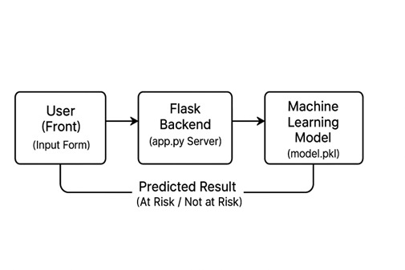

How Flask Connects the User and the Machine Learning Model:
When a user interacts with the Wind Energy Output Prediction website, Flask acts as the middle layer between the frontend (user interface) and the backend (machine learning model).
Here’s how the process works step by step:
1. User Input: The user opens the website and fills out a form with details such as wind speed, humidity, Temperature, etc.
2. Data Submission: When the user clicks “Predict Energy Output”, Flask receives this information on the server side.
3. Model Processing: Flask passes the input data to the pre-trained machine learning model (saved as model.pkl) for analysis.
4. Prediction Generation: The model predicts the energy output of a wind turbine in MWPH based on user input.
5. Result Display: Flask sends the prediction result back to the webpage, where it is displayed in a user-friendly format.

CHAPTER 2
REVIEW OF LITERATURE

Wind energy prediction has been a growing research area in the field of renewable energy and artificial intelligence. Several studies have explored different approaches to forecast wind power output using meteorological data and machine learning techniques. Traditional statistical methods such as ARIMA and linear regression were initially used to model wind speed and power generation, but these models struggled to capture the nonlinear and complex relationships between weather parameters and turbine output.

Recent advancements in machine learning (ML) have significantly improved prediction accuracy. Techniques such as Support Vector Machines (SVM), Artificial Neural Networks (ANN), and Random Forest (RF) have shown strong performance in handling large datasets and nonlinear dependencies. Among these, Random Forest models have gained attention for their robustness, high accuracy, and ability to handle noise in meteorological data. Studies have demonstrated that ensemble models like Random Forest outperform single predictive algorithms by combining multiple decision trees to produce more stable and precise results.

In addition, the integration of real-time weather data and IoT-based monitoring systems has further enhanced predictive capabilities. Researchers have also explored hybrid models that combine ML with optimization or deep learning methods to improve adaptability across different turbine types and geographic locations.

Building upon this literature, the present project adopts a Random Forest-based approach for predicting wind turbine energy output. By leveraging parameters such as air density, humidity, temperature, and blade length, this system provides a reliable and scalable solution for efficient energy management and smart grid applications.

2.1 Applications of Machine Learning:
Machine Learning (ML) has become one of the most transformative technologies across various industries, enabling computers to learn from data and make intelligent decisions without explicit programming. Its adaptability and predictive power make it suitable for solving real-world problems in numerous domains. Some key applications are outlined below:

1. Healthcare and Medical Diagnosis: Machine learning models are widely used in healthcare for disease prediction, medical image analysis, and personalized treatment planning. Algorithms can detect early signs of diseases such as cancer, diabetes, and mental health disorders by analyzing patient records, genetic data, and behavioral patterns. In this project, ML is applied to predict mental health conditions and identify individuals at risk, promoting early intervention and awareness.

2. Finance and Banking: In the financial sector, ML is used for fraud detection, credit risk assessment, algorithmic trading, and customer segmentation. Models analyze transaction patterns to detect suspicious activities and minimize financial losses.

3. Education: Machine learning supports adaptive learning platforms that personalize educational content based on students’ performance. It helps predict student dropout risks, recommend learning resources, and improve academic outcomes.

4. E-Commerce and Marketing: Online retailers use ML algorithms for product recommendations, customer behaviour analysis, and targeted advertising. Predictive models enhance user experience and increase sales by suggesting products relevant to user preferences.

5. Cybersecurity: ML algorithms detect malware, phishing attacks, and other security breaches by learning from historical patterns of cyber threats. This enhances the ability to prevent and respond to potential attacks.

6. Agriculture: Machine learning is used to predict crop yields, monitor soil conditions, and detect plant diseases through image recognition, thereby improving agricultural productivity and sustainability.

2.2 Why Wind Energy Output Prediction Using ML:

1. Efficient Development: Machine Learning allows for efficient and intelligent development of predictive systems by automating data analysis and model training. Instead of relying on static mathematical equations, ML models dynamically learn from large datasets, improving prediction accuracy with minimal manual intervention.

2. Modularity and Reusability: The system is designed in a modular architecture — separate layers for data collection, preprocessing, model training, and prediction. This modularity ensures that each component (e.g., model, dataset, frontend, backend) can be updated or reused independently without affecting the entire system.

3. Real-Time Interaction: By integrating Flask with a trained ML model, users can input live weather data and receive instantaneous predictions on the web interface. This real-time prediction capability makes the application interactive, efficient, and user-friendly for both research and operational purposes.

4. Scalability and Performance: The model and web system can easily scale to handle larger datasets or additional weather parameters. With cloud integration or API support, the system’s performance can be optimized for industrial-scale deployment in wind farms and energy management systems.

5. Rich User Experience: The web-based interface, built using HTML and CSS, provides a clean and intuitive user experience. Users can visualize predictions quickly and clearly, enhancing usability for both technical and non-technical audiences.

6. Developer Community and Ecosystem: Built on open-source technologies like Python, Flask, Pandas, and Scikit-learn, the project benefits from a vast developer ecosystem. Continuous community support ensures easy maintenance, integration of new ML techniques, and long-term sustainability of the system.

2.3 Scope:

The scope of this project extends to developing a robust and intelligent system capable of predicting wind turbine energy output based on meteorological parameters such as wind speed, humidity, temperature, and air pressure. The integration of machine learning techniques allows for accurate forecasting and improved decision-making in renewable energy management. This project aims to assist energy producers, engineers, and researchers in optimizing wind power generation and ensuring better grid stability by minimizing dependency on non-renewable sources.

Furthermore, the system is designed with scalability in mind, enabling future integration with live weather APIs and real-time monitoring dashboards. The modular architecture makes it adaptable for various climatic regions and turbine types, allowing for model retraining with new data. Beyond energy forecasting, this framework can be extended to other renewable domains such as solar energy prediction and hybrid energy optimization. Thus, the project not only contributes to current sustainable energy efforts but also lays the foundation for future advancements in smart energy management systems.

2.4 Project Introduction:
The project focuses on developing an intelligent system that accurately forecasts the energy output of wind turbines using weather-related parameters. Wind energy is one of the fastest-growing renewable energy sources, but its efficiency heavily depends on variable meteorological conditions such as wind speed, temperature, humidity, and air pressure. This project uses advanced ML techniques, particularly the Random Forest algorithm, to analyze these parameters and predict the energy generated under specific environmental conditions.

The main goal of this project is to provide an efficient, data-driven solution that helps optimize energy production, enhance grid stability in renewable energy management. The system is built with a Flask-based backend for processing and model deployment, and a user-friendly frontend designed with HTML and CSS, allowing real-time predictions through an interactive interface. By combining data analytics, machine learning, and web technology, this project demonstrates how artificial intelligence can be applied to achieve sustainable energy forecasting and promote smarter, eco-friendly power generation systems.
2.5 Process:
The project begins with collecting and understanding historical wind turbine data, which includes key parameters like air density, temperature, humidity, blade length, and the corresponding power output. The dataset you are using contains over 50,000 records, providing a robust foundation for machine learning. Understanding the dataset involves analyzing distributions, ranges, and correlations among features to identify which variables significantly influence energy production. This step ensures that the model is trained on relevant and meaningful inputs.

After understanding the dataset, preprocessing is performed to make the data suitable for modeling. Although the dataset has no missing values, normalization or scaling of features like air density and temperature can help improve model performance. Feature engineering can also be applied, such as creating interaction features between environmental factors and blade length. This step prepares the data for machine learning algorithms and ensures consistency in the inputs fed to the model.

Machine learning models are then selected and trained to predict wind turbine power output based on the input features. Models such as Random Forest, Gradient Boosting, or Neural Networks are suitable for this regression task. The dataset is split into training and testing sets, and the model learns patterns in how environmental conditions and blade characteristics affect energy output. Hyperparameter tuning and cross-validation are applied to enhance accuracy and prevent overfitting, ensuring the model generalizes well to unseen data.

Once trained, the model is evaluated using metrics like Mean Squared Error (MSE) and R² score to measure prediction accuracy. After validation, the model is integrated into a Flask-based web application, enabling real-time predictions of wind turbine energy output based on live input values. This deployment allows operators to forecast power generation, optimize turbine performance, and plan energy distribution efficiently. Continuous monitoring and model retraining with new data ensure that predictions remain accurate over time, making the system robust and practical for real-world usage.

2.6 Objectives:

The primary objective of this project is to develop a machine learning-based model to accurately predict the energy output of wind turbines using historical and real-time data. The project aims to collect and preprocess relevant data, including wind speed, direction, temperature, air density, and past energy production, while handling missing values and outliers for reliable analysis. Key features influencing turbine performance will be identified and engineered to enhance prediction accuracy. Multiple machine learning algorithms, such as Linear Regression, Random Forest, and Neural Networks, will be trained and evaluated using metrics like RMSE and R².

The model will enable short-term and long-term energy output forecasting to support efficient turbine management. Insights from predictions will help optimize energy generation and inform maintenance schedules. The project also aims to provide a user-friendly interface or dashboard for visualizing real-time predictions. Overall, this study seeks to enhance renewable energy planning and maximize wind turbine efficiency through data-driven methods.

2.7 Features:

Wind speed is the most crucial factor affecting the energy output of a wind turbine. Higher wind speeds generally result in more power generation, while very low or extremely high speeds can reduce efficiency or even shut down the turbine. Measuring wind speed at hub height ensures accurate input for prediction.

The direction of the wind impacts how effectively the turbine blades capture energy. Turbines are designed to rotate toward the wind, and incorrect alignment can lower energy output. Including wind direction as a feature helps the model understand variations in efficiency.

Temperature affects air density, which is the mass of air per unit volume. Denser air generates more force on turbine blades, leading to higher energy output. By considering both temperature and calculated air density, the model can better predict actual power production.

Humidity influences air density and turbine aerodynamics. High humidity slightly reduces air density, which can decrease power output. Including this feature allows the model to account for environmental variations.

Features like turbine RPM and blade pitch angle directly impact energy generation. RPM shows the rotational speed of the turbine, while pitch angle controls blade efficiency. These operational metrics help the model capture turbine performance under varying wind conditions.

Historical energy output provides patterns and trends that improve prediction accuracy. Including date and time as features allows the model to consider seasonal and daily wind variations, enabling both short-term and long-term forecasting.

2.8 Existing System:

The existing systems for predicting wind turbine energy output primarily rely on a single-parameter dataset, typically focused only on wind speed. While wind speed plays a crucial role in determining turbine performance, this limited approach fails to capture the complex and dynamic interactions between multiple environmental factors that significantly influence energy generation. As a result, the predictions from such systems often lack accuracy and reliability under varying weather conditions.

Wind energy generation is highly dependent on unpredictable weather conditions, leading to fluctuations in output. These variations create difficulties in energy planning, storage, and distribution. Current systems often lack accurate forecasting models that combine multiple weather parameters effectively.

CHAPTER 3
PROPOSED SOLUTION

This Chapter delves into the structure of WIND TURBINE ENERGY PREDICTION USING ML, exploring how the system is meticulously crafted for user-friendliness and examining its various layers.

3.1 Proposed Solution:

To address the challenge of accurately predicting wind turbine energy output, the proposed solution involves developing a machine learning-based predictive model. The system will collect historical and real-time data from wind turbines, including wind speed, direction, temperature, air density, humidity, and turbine operational parameters. This data will be preprocessed to handle missing values, outliers, and inconsistencies, ensuring high-quality input for the model.

Feature engineering will be applied to extract meaningful patterns from the collected data. Derived features, such as wind power density and turbine efficiency ratios, will help the model better understand the relationships between environmental conditions and energy output. The dataset will then be split into training and testing sets to develop and evaluate different machine learning models.

Multiple machine learning algorithms, such as Linear Regression, Random Forest, XGBoost, and Neural Networks (MLP or LSTM), will be trained and compared. The model with the best performance based on metrics like RMSE, MAE, and R² will be selected for final implementation. This approach ensures that the solution is both accurate and adaptable to changing wind conditions.

Finally, the system will include a dashboard or visualization interface to display predicted energy output in real-time. This will allow wind farm operators to optimize turbine operation, plan maintenance, and improve overall energy management. By leveraging machine learning, the proposed solution aims to maximize wind energy efficiency and support reliable renewable energy integration.

3.2 Proposed System Architecture:

The architecture of the proposed system is designed to ensure efficient data processing, modularity, and real-time interaction between the user and the predictive model. It follows a three-tier architecture, consisting of the Frontend Layer, Backend Layer, and Machine Learning Model Layer, all interconnected through the Flask framework.

1. Frontend Layer (User Interface): The frontend is built using HTML, CSS, and JavaScript, providing a clean and interactive interface for users. It consists of input forms where individuals enter personal details such as age, gender, occupation, and stress levels. Once the form is submitted, the data is securely sent to the backend for processing. This layer ensures simplicity, accessibility, and ease of use for non-technical users.

2. Backend Layer (Flask Application): Flask acts as the backbone of the system, connecting the frontend with the machine learning model. It receives user input, formats it appropriately, and sends it to the trained model for prediction. Flask also handles routing, data validation, and response generation, ensuring smooth communication between the user and the predictive engine.

3. Machine Learning Model Layer: This layer contains the trained Random Forest Classifier, which performs the actual prediction. The model has been trained on preprocessed survey data and stored as a .pkl file. The model layer ensures high accuracy and interpretability through the use of ensemble learning techniques.
4. Data Source: The system can be connected to a database or an external CSV dataset for storing training data and user input logs. This allows retraining the model periodically with updated data, improving its performance and adaptability over time.

5. Output Generation: After prediction, Flask displays the result on the web interface in a clear and interpretable format. The output not only indicates the predicted risk level but can also show the probability score to give users a better understanding of their mental health status.

The interaction between these layers ensures that user data flows smoothly from input to prediction, maintaining both efficiency and reliability. The modular nature of the architecture allows easy upgrades — for instance, replacing the Random Forest model with another algorithm or integrating additional features without redesigning the entire system.

Frontend Layer
( HTML, CSS, JAVASCRIPT )

Backend Layer
( Flask )

MACHINE LEARNING LAYER
( Random Forest )

DATASET LAYER
(CSV Dataset)

Figure: Layered Architecture

3.3 System Design:

System design is a vital phase in software development that defines how the system’s individual components work together to achieve the desired objectives. In the “Wind Turbine Energy Output Prediction Using Machine Learning” project, the system design focuses on creating a seamless flow between the user interface, data processing, machine learning model, and result visualization. The design aims to ensure efficiency, modularity, accuracy, and user-friendliness while maintaining secure and ethical handling of user information.

The proposed system follows a modular and layered design, where each component performs a specific function and interacts with others through well-defined interfaces. This modularity allows for easy scalability, debugging, and future enhancements without affecting the entire structure. The system’s architecture is divided into several logical parts, including the frontend, backend, and machine learning model integration.

The user interface is designed using web technologies such as HTML, CSS, and JavaScript to provide a clean, interactive, and responsive experience for users. It allows individuals to input details such as wind speed, blade length, humidity, temperature, etc. The interface is intentionally kept simple and intuitive, making it accessible to users of all backgrounds, including those without technical expertise. Once the data is submitted, it is transmitted to the backend through Flask, ensuring a smooth and secure data transfer.

The backend layer, developed using the Flask framework, serves as the communication bridge between the frontend and the machine learning model. It receives the user input from the web form, performs necessary validation, and preprocesses the data to match the format required by the trained model. This ensures that all input data is consistent, accurate, and ready for analysis. Flask then passes this processed data to the machine learning module for prediction.

At the core of the system lies the machine learning model, which performs the primary prediction task. A Random Forest Classifier is employed for its robustness, high accuracy, and ability to handle both categorical and numerical variables effectively. The model has been trained on a well-structured dataset containing metrological data and historical data. Prior to training, the dataset underwent several preprocessing steps such as handling missing values, encoding categorical attributes, and feature scaling. After achieving satisfactory accuracy and performance, the model was serialized using pickle and saved as a .pkl file for integration into the Flask application.

The prediction process begins when Flask loads the trained model and sends it the processed input data. The model analyses these attributes and returns a prediction, classifying the output. This output is then sent back to the backend, which formats the response and delivers it to the frontend for display. The output interface presents the results in a clear and easily interpretable form, helping users understand their mental health status. The prediction may also include a probability score, offering additional insight into the confidence of the model’s decision.

To enhance the system’s reliability and future usability, an optional database component can be integrated for storing user data and prediction results. This allows the model to be retrained periodically using updated data, improving its accuracy and relevance over time. Furthermore, the design incorporates basic security and privacy measures to protect user information, ensuring that personal data is not stored or shared without consent. These measures align with ethical standards for handling sensitive health-related information.

Overall, the system design ensures efficient data flow, modularity, and real-time interaction between all components. The integration of the machine learning model with a user-friendly web interface makes the system both practical and impactful.

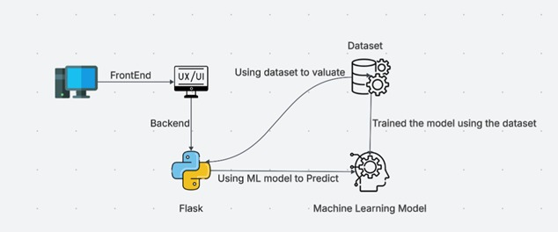

Figure: System Design

3.4: UML Diagrams:

UML stands for Unified Modelling Language. UML is a standardized general-purpose modeling language in the field of object-oriented software engineering. The standard is managed and was created by, the Object Management Group.

USE CASE DIAGRAM:

A use case diagram in the Unified Modelling Language (UML) is a type of behavioural diagram defined by and created from a Use-case analysis. Its purpose is to present a graphical overview of the functionality provided by a system in terms of actors, their goals (represented as use cases), and any dependencies between those use cases.

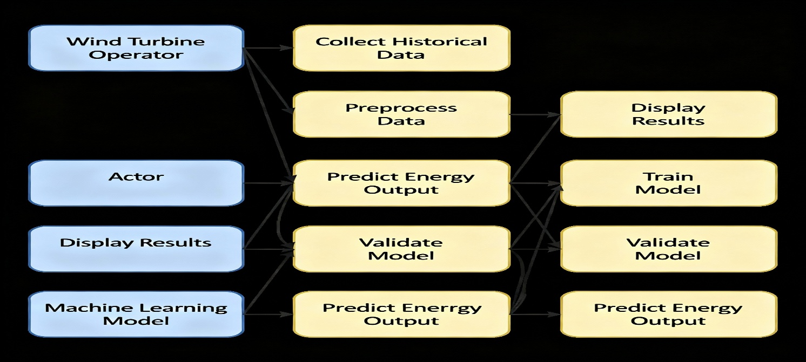

Figure: Use Case Diagram

CLASS DIAGRAM:

In software engineering, a class diagram in the Unified Modelling Language (UML) is a type of static structure diagram that describes the structure of a system by showing the system classes, their attributes, operations (or methods), and the relationships among the classes. It explains which class contains information.

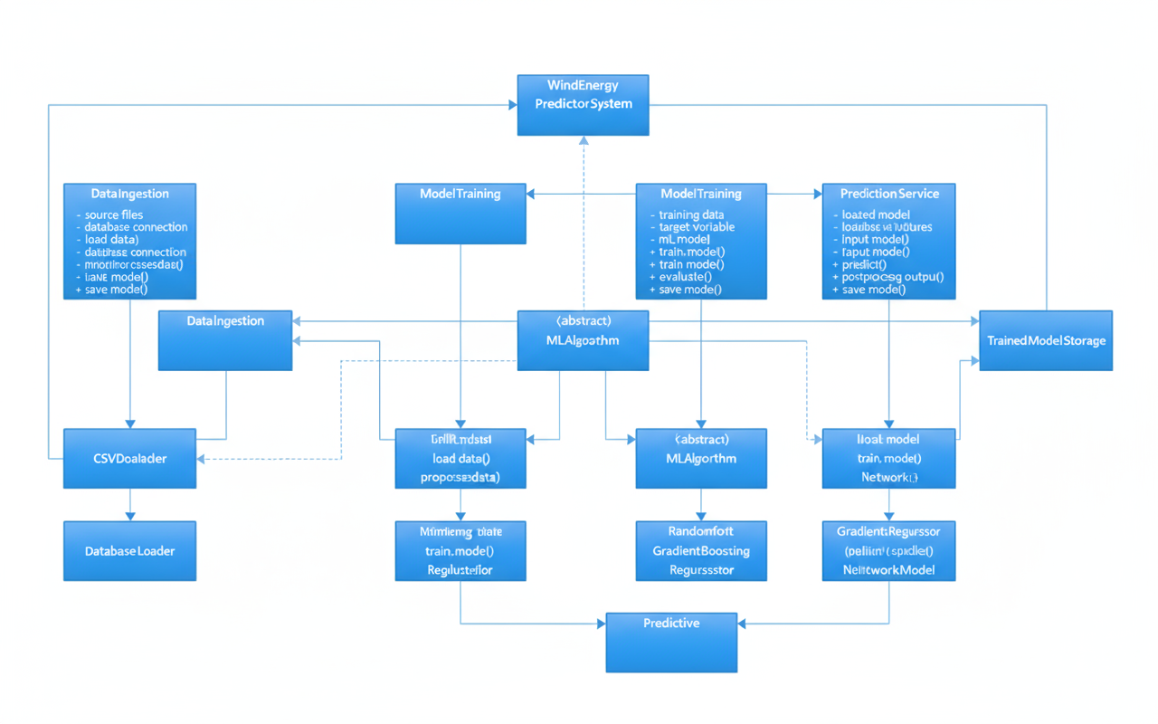

Figure: Class Diagram

COMPONENT DIAGRAM:

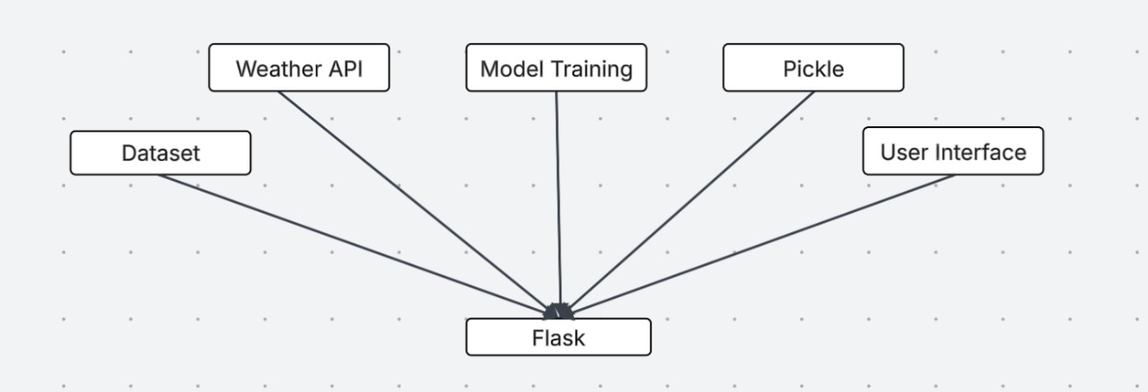

Figure: Component Diagram

In UML, component diagrams show the structure of the software system, which describes the software components, their interfaces, and their dependencies.

SEQUENCE DIAGRAM:

A sequence diagram in Unified Modelling Language (UML) is a kind of interaction diagram that shows how processes operate with one another and in what order. It is a construct of a Message Sequence Chart. Sequence diagrams are sometimes called event diagrams, event scenarios, and timing diagrams.

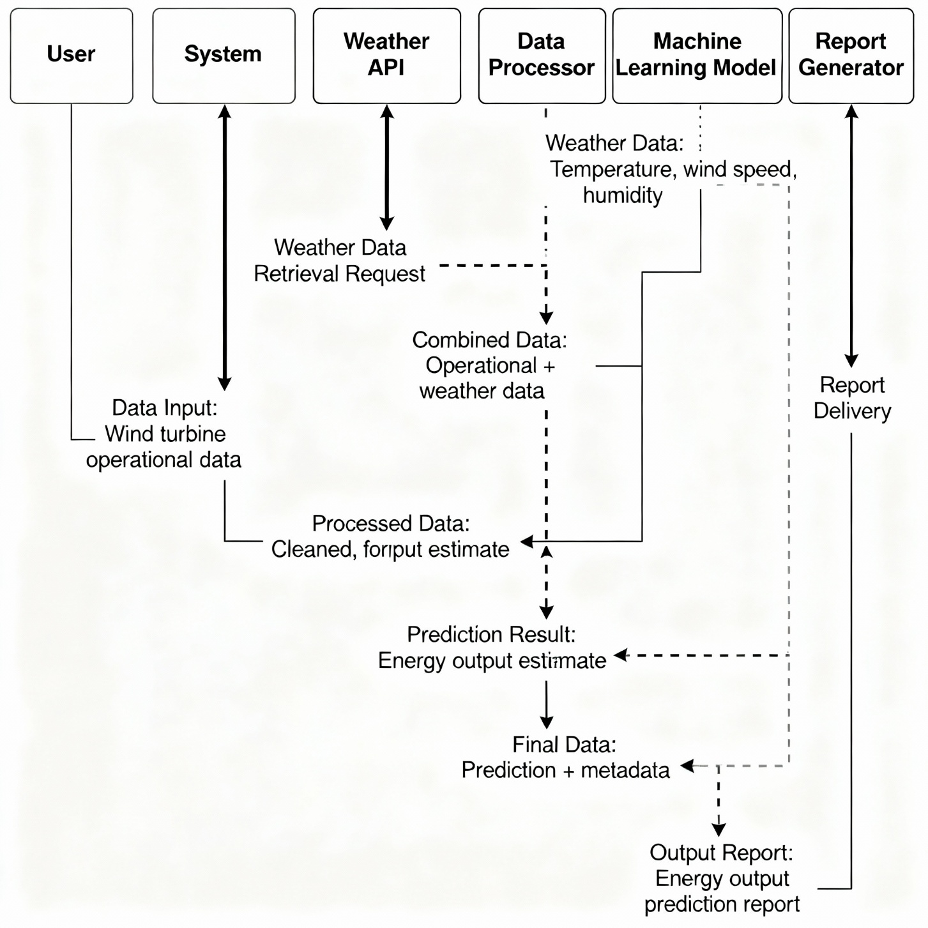

Figure: Sequence Diagram
DEPLOYMENT DIAGRAM:

Deployment diagrams show the relationships between the software and hardware components in the system and the physical distribution of the processing.

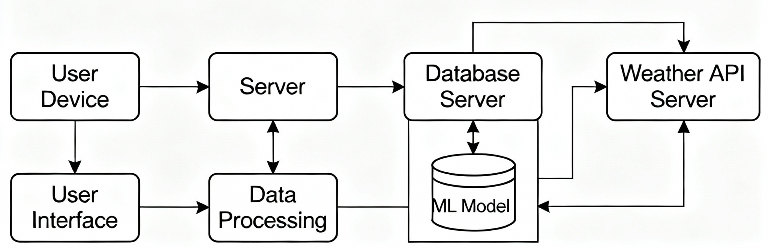

Figure: Deployment Diagram

CHAPTER 4
IMPLEMENTATION

This chapter gives a detailed view of website technologies and their installation process to be used in an Integrated Development Environment (IDE)

4.1 Visual Studio Code:

Visual Studio Code (VS Code) is a free, open-source code editor developed by Microsoft. It is designed for me with a wide range of programming languages and supports a variety of features that make it a popular choice among developers.

Here are some of the main features of Visual Studio Code:

1. Cross-platform support: Visual Studio Code works on all major operating systems, including Windows, Mac, and Linux

2. IntelliSense: Visual Studio Code provides intelligent code completion, syntax highlighting, and error checking for a wide range of programming languages, including Python, JavaScript, and C

3. Integrated debugging. Vinul Studio Code includes a built-in debugger that allows you to step through your code, set breakpoints, and inspect variables in real-time.

4. Extension marketplace: Vimal Studio Code has a robust marketplace for extensions, with thousands of extensions available for everything from code formatting to testing frameworks.

5. Git integrations: Visual Studio Code includes built-in Git support, allowing you to easily manage your code repositories and collaborate with other developers.

6. Customizable interface: Visual Studio Code allows you to customize your interface with themes and icons, and supports a variety of keyboard shortcuts and other productivity features.

Overall, Visual Studio Code is a powerful and flexible code editor that provides a wide range of features for developers.

4.2 Flask: A Micro Framework

Flask is a lightweight and flexible web framework written in Python, used for developing web applications. It follows the Model-View-Controller (MVC) architectural pattern, which helps in separating the logic, user interface, and data layers of an application. Flask is known for its simplicity, scalability, and modularity, allowing developers to quickly create and deploy web-based systems. It includes built-in tools for routing, templating, and handling HTTP requests, but allows developers to extend its functionality using external libraries. Flask is particularly suitable for integrating machine learning models into interactive web applications, making it a popular choice for AI and data-driven projects.
The installation process of Flask in conjunction with Visual Studio Code:

4.2.1 Install Python:

Ensure that the latest version of Python is installed on your system.

During installation, enable the option “Add Python to PATH” to allow global access to Python commands.

You can verify the installation using the command:

bash: python --version

4.2.2 Install Visual Studio Code:

Download and install Visual Studio Code from the official website:

https://code.visualstudio.com.

After installation, open VS Code and install the Python extension by Microsoft, which provides support for Python syntax, debugging, and virtual environments.

4.2.3 Set Up a Virtual Environment:

Creating a virtual environment isolates project dependencies.

Activate the virtual environment:

bash: python -m venv venv

On Windows:

bash: venv\Scripts\activate

4.2.4 Install Flask Framework:

Once the environment is active, install Flask using the Python package manager (pip):

bash: pip install flask

Verify the installation by running:

bash: flask --version

4.3 HTML, CSS, JAVASCRIPT :

HTML (Hypertext Markup Language):

HTML (Hypertext Markup Language) is the standard markup language used to structure and present content on the web. It defines the basic framework of web pages through elements such as headings, paragraphs, links, forms, tables, and images. In this project, HTML forms the foundation of the web interface by creating input fields and layout structures that allow users to enter relevant information for mental health prediction. It serves as the skeleton of the application, upon which styling (CSS) and interactivity (JavaScript) are applied.

CSS (Cascading Style Sheets) :

CSS (Cascading Style Sheets) is a stylesheet language used to describe the presentation and visual appearance of a web page created with HTML. It controls aspects such as layout, colours, fonts, spacing, and responsiveness, ensuring a consistent and visually appealing design across different devices and screen sizes. In this project, CSS enhances the user experience by making the web interface clean, intuitive, and engaging, allowing users to interact comfortably with the prediction system.

JavaScript (JS) :

JavaScript is a versatile scripting language that enables interactivity and dynamic functionality within web pages. It allows developers to create responsive behaviours such as form validation, interactive elements, and real-time updates without reloading the entire page. In the Mental Health Prediction project, JavaScript plays a crucial role in managing client-side interactions—such as capturing user inputs, handling data submissions, and updating prediction results dynamically—thereby improving performance and overall user experience.

4.4 Random Forest:

Random Forest is a supervised machine learning algorithm that is widely used for both classification and regression tasks. It is an ensemble learning technique, meaning it combines multiple individual models (specifically, decision trees) to produce a more accurate and stable prediction. The core idea behind Random Forest is to build a “forest” of decision trees, each trained on a random subset of the data and a random subset of features. This randomness ensures that each tree is unique, reducing overfitting and improving generalisation to unseen data.

During training, the algorithm constructs many decision trees, each of which independently learns to make predictions. When predicting, the Random Forest aggregates the outputs of all trees — for classification, it takes the majority vote (the class most trees agree on), while for regression, it computes the average of all predictions. This ensemble approach helps mitigate the bias and variance issues commonly found in single decision trees, leading to higher accuracy and robustness.

In the context of wind energy prediction, Random Forest can efficiently analyze multiple environmental factors such as wind speed, air density, temperature, and turbine characteristics to accurately forecast energy output.

4.5 Pickle:

Pickle is a Python module used for serializing and deserializing Python objects. Serialization (also called pickling) is the process of converting a Python object — such as a list, dictionary, model, or custom class — into a byte stream that can be stored in a file or transmitted over a network. Deserialization (or unpickling) is the reverse process, where the byte stream is converted back into the original Python object. This allows developers to save complex data structures or trained models and reuse them later without retraining or reconstructing them from scratch.

In the context of Machine Learning, Pickle is commonly used to save trained models. After a model is trained using libraries like scikit-learn, it can be serialized and saved as a .pkl file using pickle.dump() or joblib.dump(). Later, when the application (such as your Flask web app) needs to make predictions, the model can be quickly loaded back into memory using pickle.load() or joblib.load() without retraining. This approach enhances efficiency, portability, and deployment speed.

This allows you to save your trained model once and reuse it anytime without retraining — saving both time and computational resources.

4.6 System Requirements:

4.6.1 Software Requirements

Visual Studio Code – IDE(Integrated Development Environment) for coding -v1.18
Python – Programming Language – v3.9
Flask - For web application development
Scikit-learn for machine learning algorithms like Random Forest
Pandas, NumPy - For data preprocessing and analysis
Pickle - For model serialization and deployment

4.6.2 Hardware Requirements:

Computer with a capable processor (e.g., Intel Core i5)

Sufficient RAM (8 GB or more)

Stable internet connection

4.7 Pseudocode:

4.7.1 Flask Application and Model Integration:

app.py:
This file is responsible for setting up the Flask web server. It begins by importing the required libraries listed in requirements.txt (such as Flask, Pandas, NumPy, and Pickle). The application initializes a Flask instance and loads the pre-trained machine learning model stored in wind_model.pkl. When a user submits input data through the web form, Flask retrieves the form data, converts it into a numerical format, and sends it to the trained model for prediction. The model processes this data and returns the predicted wind turbine energy output. Finally, Flask sends this prediction back to the front-end template (index.html) for display. This backend acts as the bridge between the user and the machine learning model, ensuring smooth real-time interaction.

wind_model.pkl:
This file contains the serialized form of the trained Random Forest Regressor model. It is created after the training process in a separate development environment. Pickle allows the trained model to be saved in binary format and reused without retraining every time the application runs. When app.py loads, it unpickles this model into memory, ready to make predictions instantly based on new user input.

requirements.txt:
This file lists all the necessary dependencies required to run the project. It ensures that anyone deploying or testing the system can install all required libraries (like Flask, scikit-learn, numpy, pandas, etc.) in one step using a single command. This promotes environmental consistency and smooth deployment on any system or cloud server.

4.7.2 User Interface:

Templates:
This file serves as the user-facing interface of the system. It contains an HTML form where users can input meteorological parameters such as wind speed, humidity, air pressure, and temperature. Once the user clicks on the "Predict" button, the form data is sent to the Flask backend (app.py) through a POST request. After Flask processes the data and predicts the energy output using the loaded model, the result is dynamically displayed on the same webpage. This ensures a smooth, interactive experience for the user without needing multiple pages.

CHAPTER 5
RESULTS

In unravelling the culmination of our project, this chapter embarks upon the synthesis of insights gleaned from a meticulously crafted test strategy and a methodological approach that served as our compass throughout.

5.1 Test Strategy and Approach

Wind Turbine Energy Prediction System is designed to ensure that every component of the application — from the backend logic to the user interface — functions accurately, efficiently, and seamlessly. The testing begins with unit testing, where each individual function, such as data preprocessing, model loading, and prediction generation is validated to confirm that it performs as intended in isolation. Next, integration testing ensures smooth communication between the Flask backend, the trained Random Forest model, and the frontend interface. Functional testing verifies that all user interactions — such as submitting weather parameters, fetching predictions, and displaying results — work correctly and meet the system’s requirements. To maintain predictive accuracy, model validation is conducted by comparing predicted and actual wind energy output, ensuring the model remains precise and consistent. Performance testing is performed to evaluate the application’s response time and its ability to handle concurrent user requests without degradation in performance. Usability testing ensures the web interface built with HTML and CSS provides a smooth, accessible, and visually appealing experience across devices and browsers. Robustness and error handling tests check how the system responds to incorrect or missing inputs, ensuring it remains stable under edge cases. Cross-platform testing validates the app’s functionality on various operating systems and browsers, ensuring universal accessibility. Finally, system testing and acceptance testing are performed to confirm that the complete workflow—from data input to prediction output—operates as expected and meets end-user needs. Overall, this test strategy ensures that the project is reliable, scalable, and production-ready, offering an accurate, user-friendly, and efficient solution for predicting wind turbine energy output in real-world renewable energy applications.

5.2 FINAL APPLICATION SCREENS

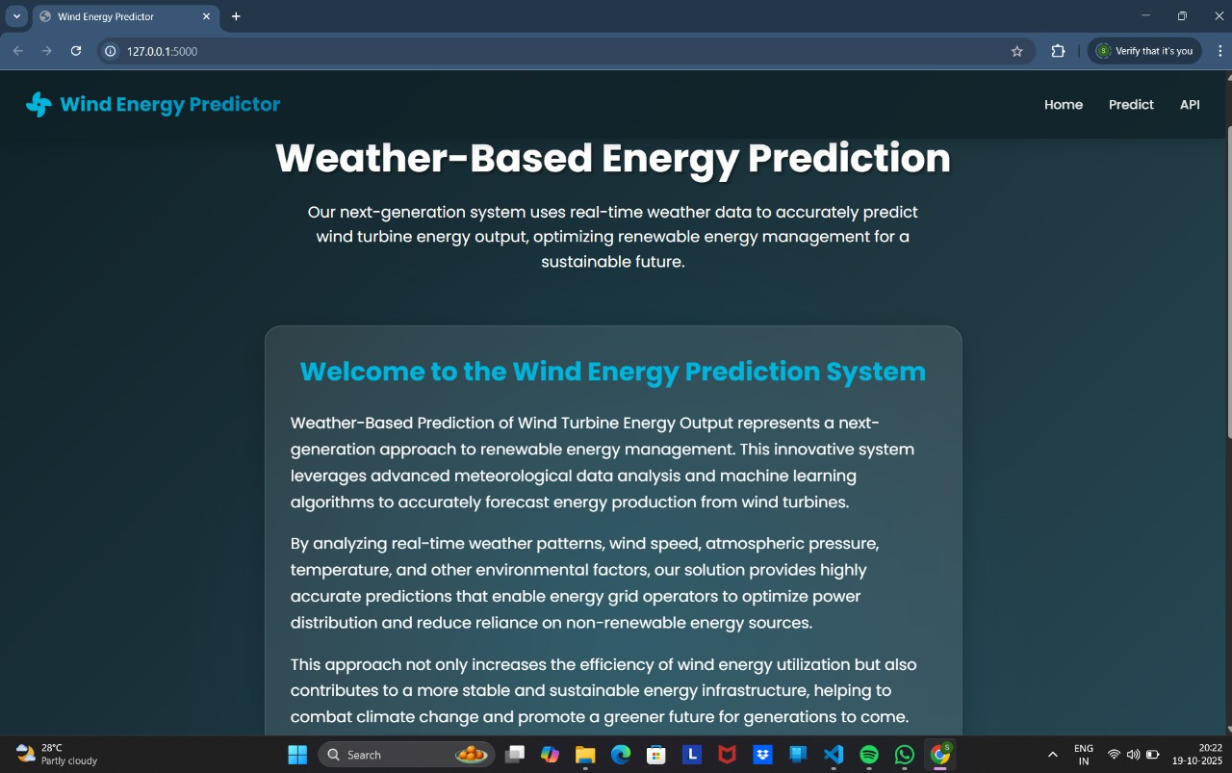

Figure: Home Page

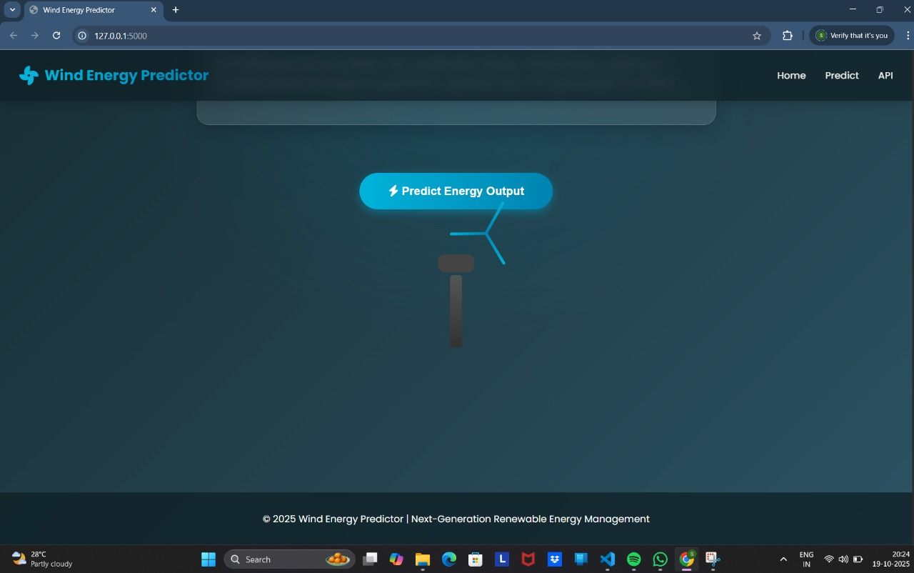

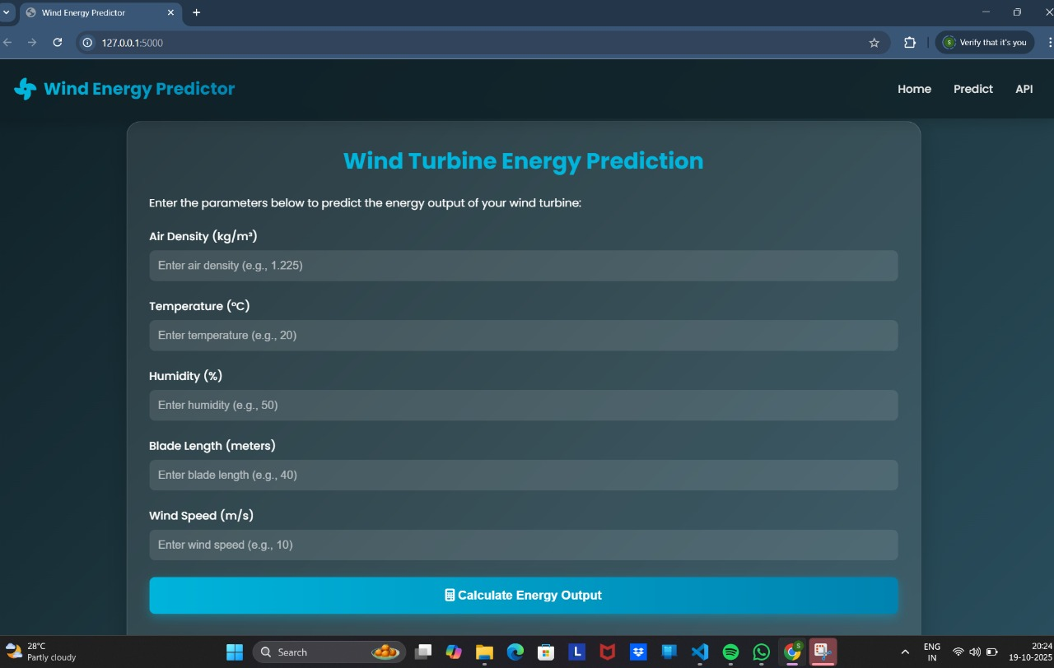

Figure: Prediction Page

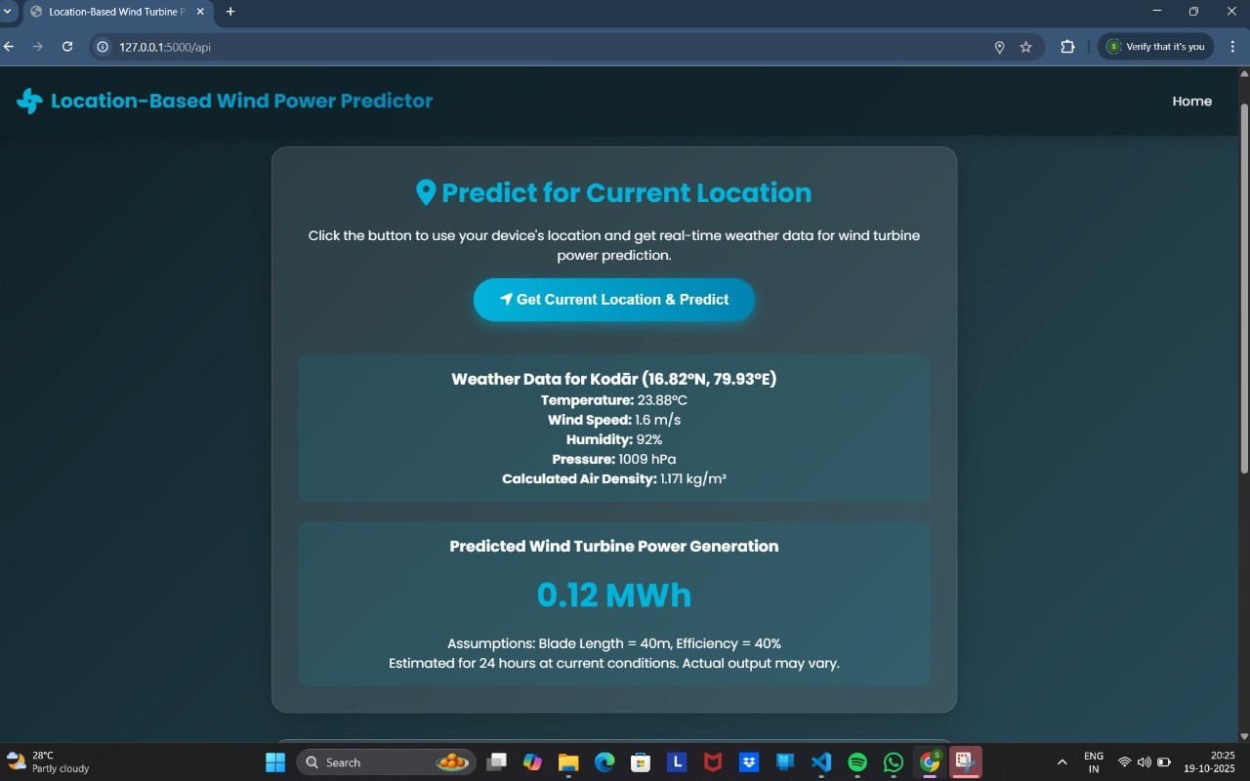

Figure: Current Location API Page

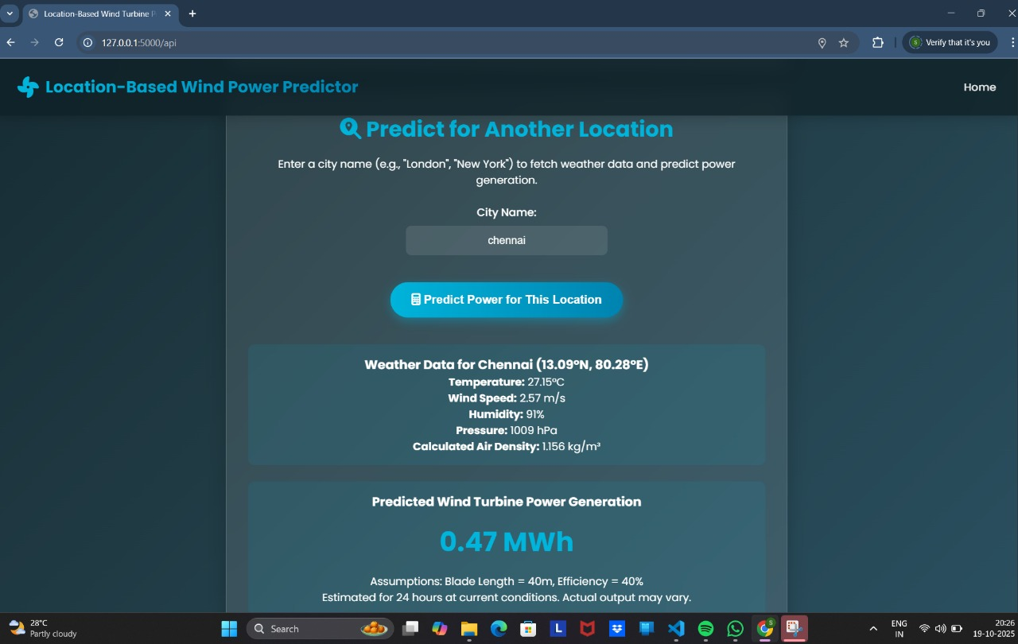

Figure: Location API Page

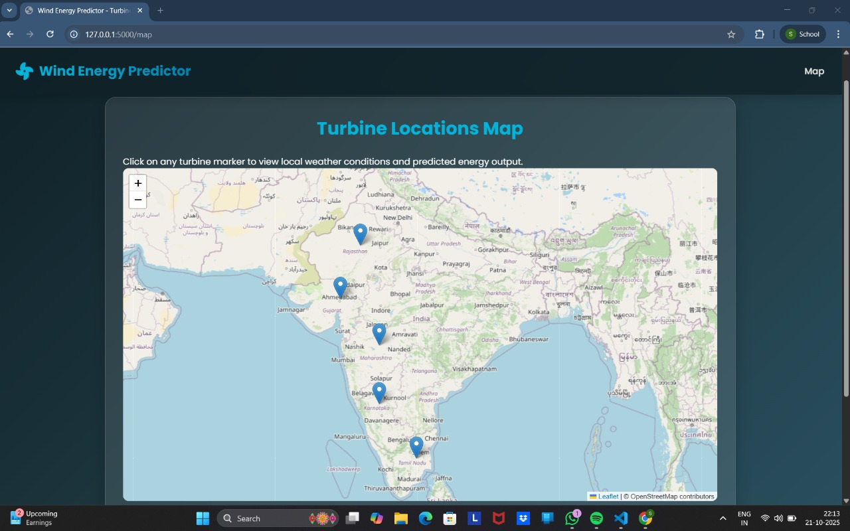

Figure: Turbine Locations Map Page

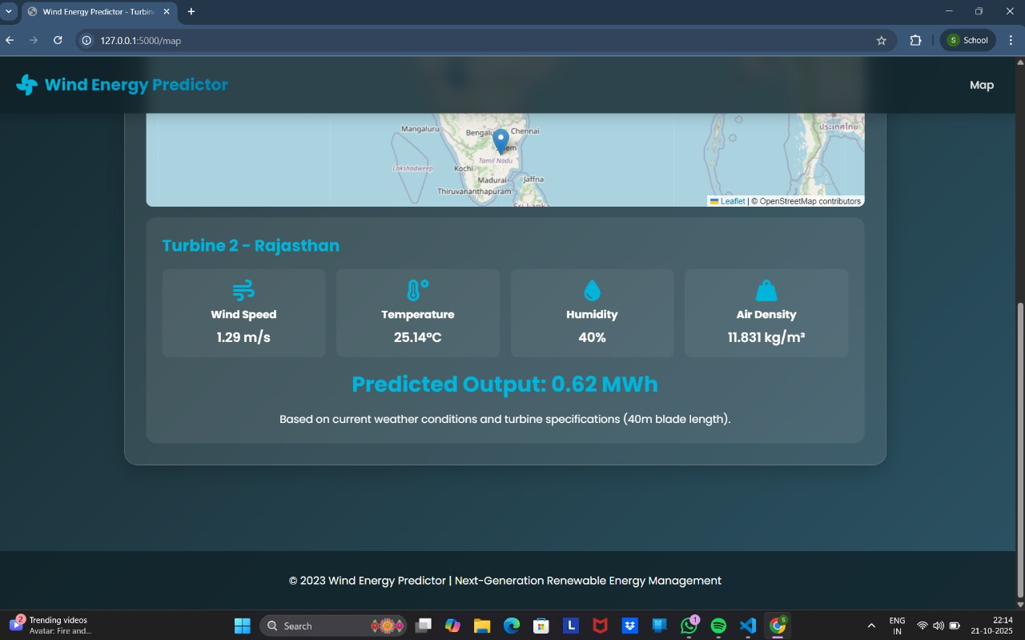

Figure: Output generation Page

CHAPTER 6
CONCLUSION AND FUTURE SCOPE

6.1 Conclusion:

The Wind Turbine Energy Prediction System successfully demonstrates how machine learning can be leveraged to enhance the efficiency and reliability of renewable energy generation. By analyzing key meteorological factors such as wind speed, humidity, temperature, and air density, the system accurately predicts the energy output of wind turbines, enabling smarter planning and energy management. The integration of a Random Forest model ensures high accuracy and robustness in predictions, while the Flask-based web application provides an intuitive and interactive platform for users to easily input parameters and obtain results in real time. Through this project, the importance of data-driven decision-making in the renewable energy sector is clearly highlighted, showing how technology can contribute to sustainability and optimized power generation. Overall, the project not only offers a scalable and user-friendly solution for energy forecasting but also lays the groundwork for future advancements such as real-time data integration, predictive maintenance, and smart grid automation — making it a valuable step toward a greener and more energy-efficient future.

6.2 Future Scope:

- Probabilistic and Uncertainty-Aware Forecasting

- Physics-Informed and Hybrid Machine Learning Models

- Real-Time Edge Deployment for Smart Wind Farms

- Predictive Maintenance and Anomaly Detection

- Explainable AI & Causality Analysis

